|  |
| --- |
| EXTEMPORE FOR IT IN AUTOMOBILES |

1.Smart and Connected Cars:

Internet of Things (IOT): Cars today are connected to the internet, providing real-time data, enabling remote monitoring, navigation, and communication.

Telematics system: These systems help track vehicle performance, monitor driver behaviour, and enhance road safety.

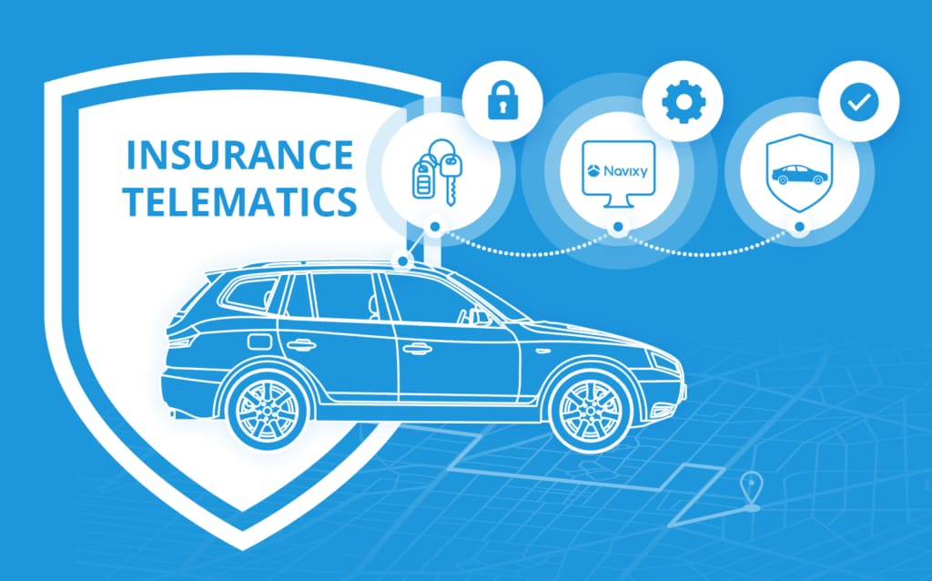

2.Autonomous Driving:

IT plays a critical role in developing self-driving cars through AI, machine learning, and sensor fusion. Advanced driver assistance system (ADAC) are making cars more autonomous. Companies like Tesla, Google’s Waymo, and others are at the forefront of this technology.

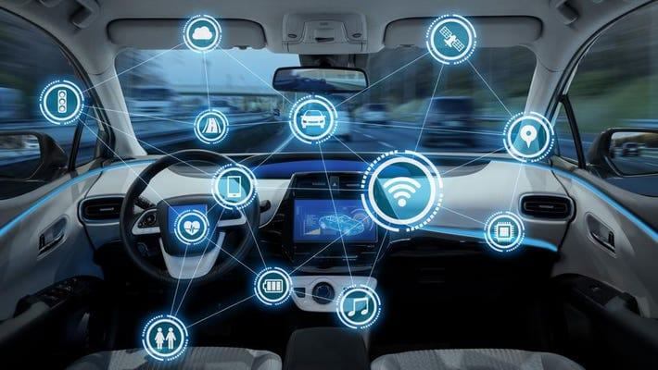

3. Software-Defined Vehicles (SDV):

Vehicles are increasingly relying on software to control major systems. Over-the-air updates allow manufacturers to update car software without requiring a visit to the dealership.

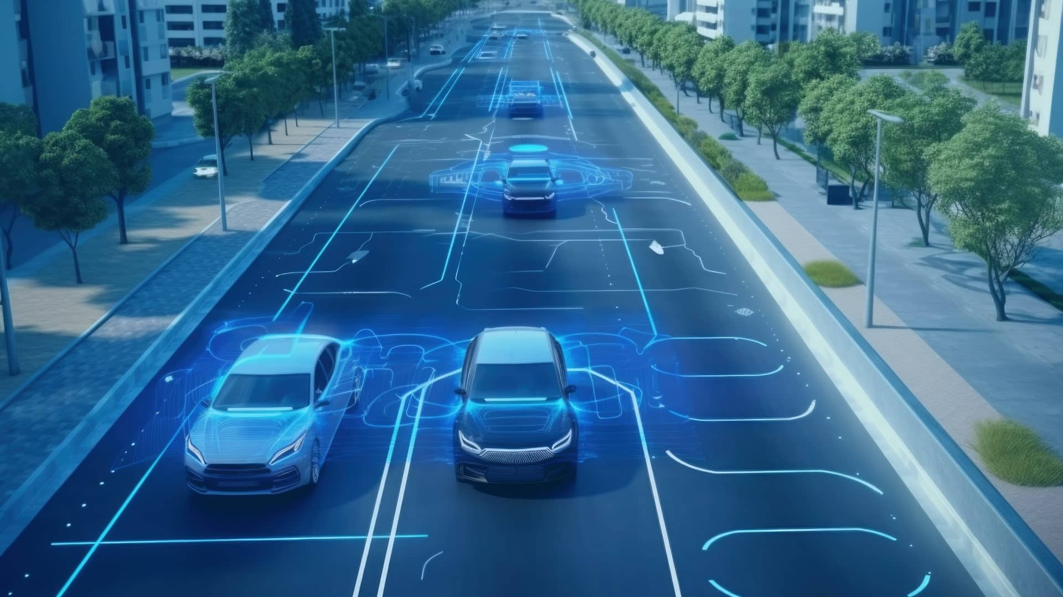

4. Predictive Maintenance:

Sensors powered by IT can predict when a vehicle might need maintenance, preventing breakdowns and increasing reliability.

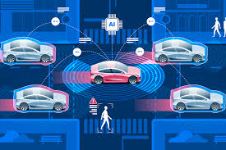

5. Electric and Hybrid Vehicles:

IT is crucial in managing the complex energy systems of electric vehicles, including battery management, charging station connectivity, and optimizing energy efficiency.

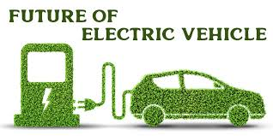

6. Cybersecurity:

As cars become more connected, the risk of cyber threats increases. IT helps build secure networks to protect vehicles from hacking and breaches.

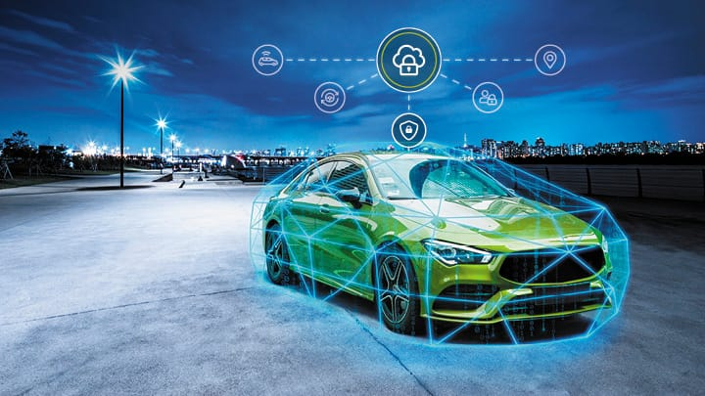

|  |
| --- |
| EXTEMPORE FOR IT IN METRORAIL |

1.Automation and Control System:

Automatic Train Operation (ATO): IT enables metro systems to have automatic train control, reducing human error and improving punctuality.

Signalling Systems: Advanced IT systems like Communication-Based Train Control (CBTC) helps monitor and control train movements, optimizing intervals and improving safety.

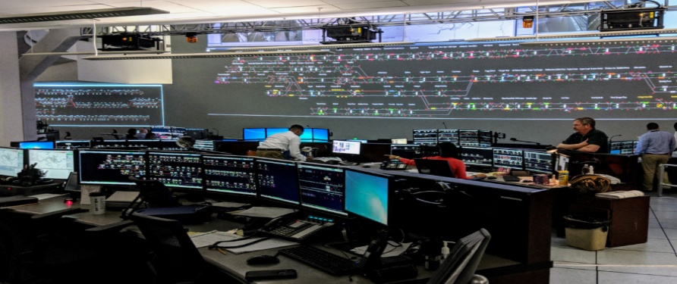

[This Photo](https://ggwash.org/view/78958/wmsc-names-metros-senior-vice-president-for-rail-transportation-in-safety-incidents) by Unknown Author is licensed under [CC BY-NC](https://creativecommons.org/licenses/by-nc/3.0/)

2.Smart Ticketing Systems:

Metros often implement contactless smart card systems or mobile apps for ticketing. These systems use IT infrastructure to manage fare collection, track passenger flow, and provide real-time information.

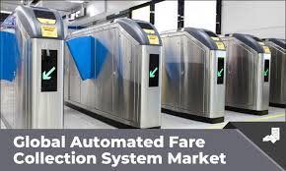

3.Real-Time Passenger Information:

Digital displays, mobile apps, and websites provide real-time updates on metro rail schedules, delays, and station information.

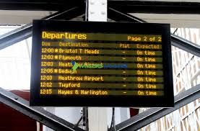

4.Smart Stations and Passenger Experience:

Include smart station design with Wi-Fi, charging points, and digital signage, mobile apps for route planning, and contactless payment systems. Emphasize the need for user-friendly interfaces and accessibility features.

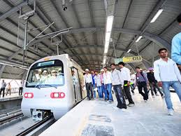

5.Cyber Security in Metro Rail:

Protecting metro systems from cyber threats by implement NIST cybersecurity framework. Integration of AI and ML for predictive security.

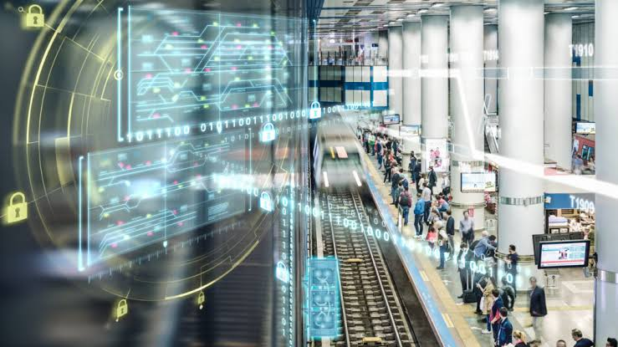

|  |
| --- |
| EXTEMPORE FOR IT IN AVIONICS |

1.The Role of IT in Avionics Systems:

IT is integrated into various avionics systems like navigation, communication, flight control, and weather monitoring. Modern aircrafts use sophisticated IT systems to monitor flight paths, optimize, and ensure communication between the ground and air.

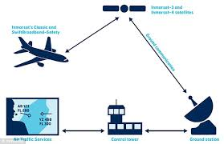

2.Advances in Flight Automation:

Autopilot systems, which use IT for real-time data analysis, helping to control the aircrafts with minimal human intervention. AI and ML are being incorporated into avionics for predictive maintenance, reducing human error, and improving safety.

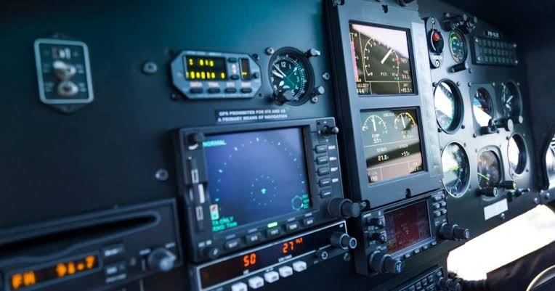

3.Cybersecurity in Avionics:

The role of IT professionals in securing aircraft networks and communication system to prevent hacking and data breaches. The increasing risk of cyberattacks on avionics systems due to their heavy reliance on IT.

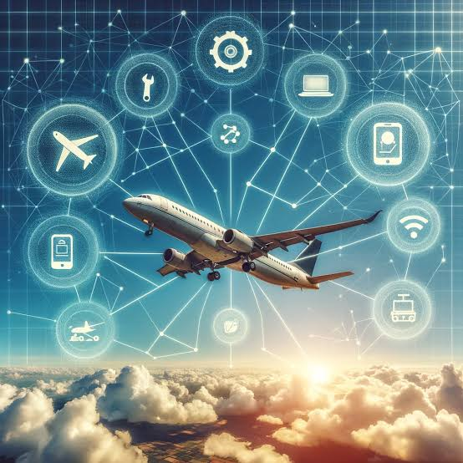

4.Real-Time Data and Big Data Analytics:

Real-Time data sharing between the aircraft and ground control is crucial for predictive maintenance, and operational efficiency.

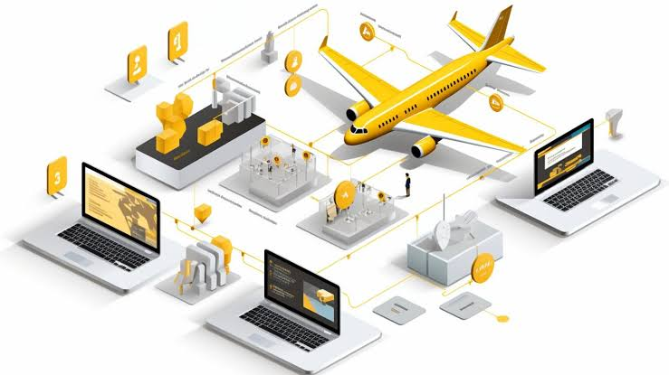

5.Future Trends in Avionics through IT:

The potential for fully autonomous flights, enhanced in-flight connectivity for passengers, and the use of augmented reality (AR) for training pilots and maintenance crews. The Internet of Things (IoT) in avionics, where sensors an aircraft will further improve monitoring and data transmission.

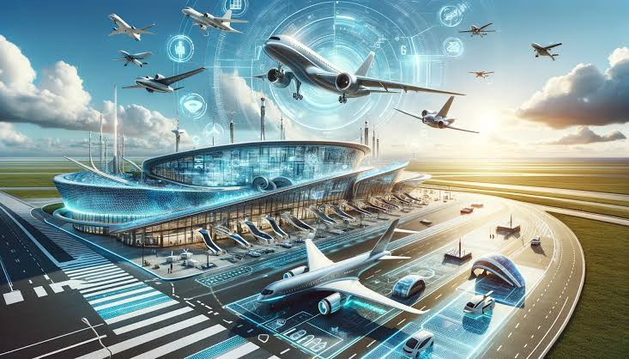

Team Mates:

Y. DURGA PRASAD

V. PRANAY KUMAR

G. ABHILASH REDDY

P. SAI

P. G.VISHWA TEJA